**Abdul Moeed**

**22-11043**

**CSCS 315-Section-A**

**Assignment 3**

**Introduction**

The task is to install and create a CI/ CD pipeline for a project using Jenkins tool. Followings are the screenshots provided for the execution of the task.

**Execution**

Java installation:

Jenkins installation:

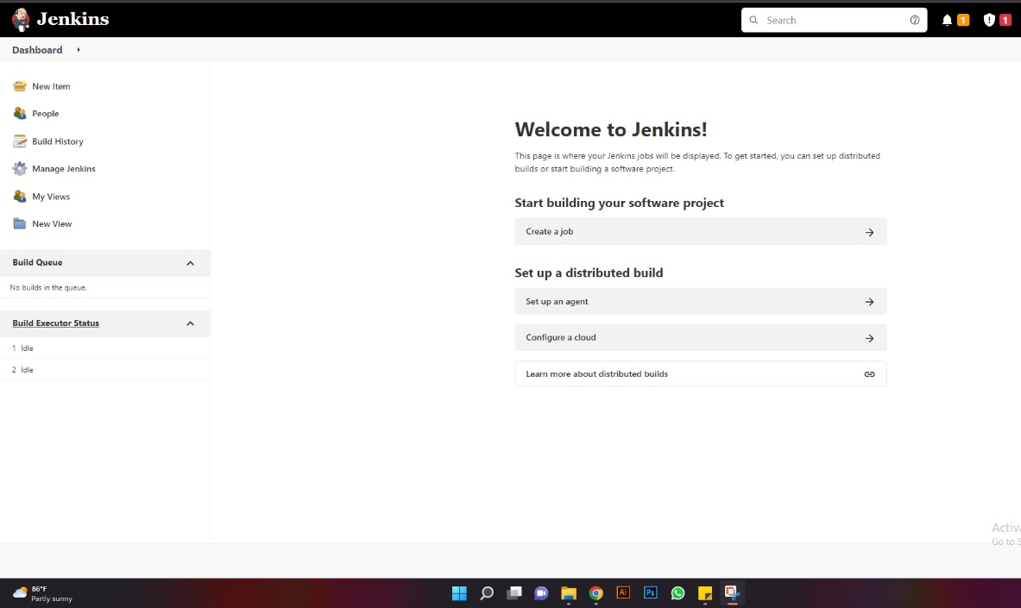

Creating pipeline:

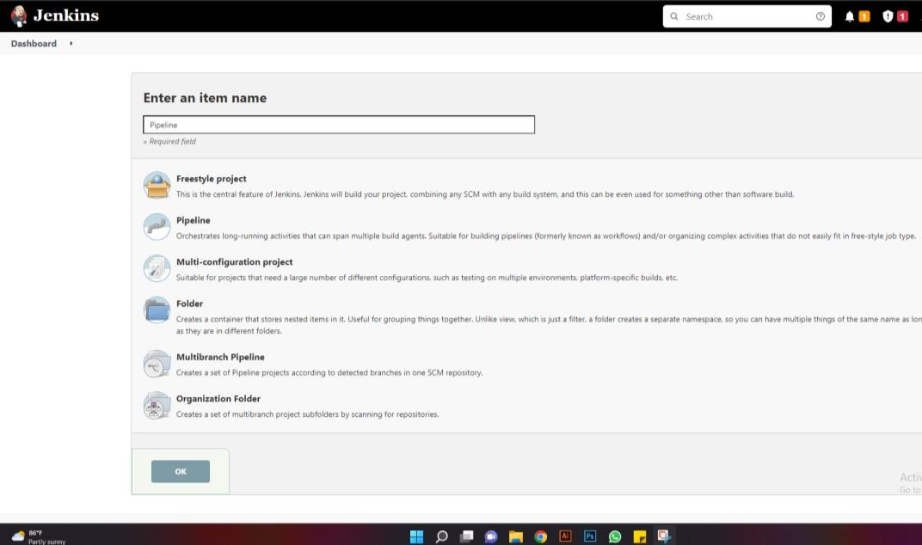

Creating pipeline stage:

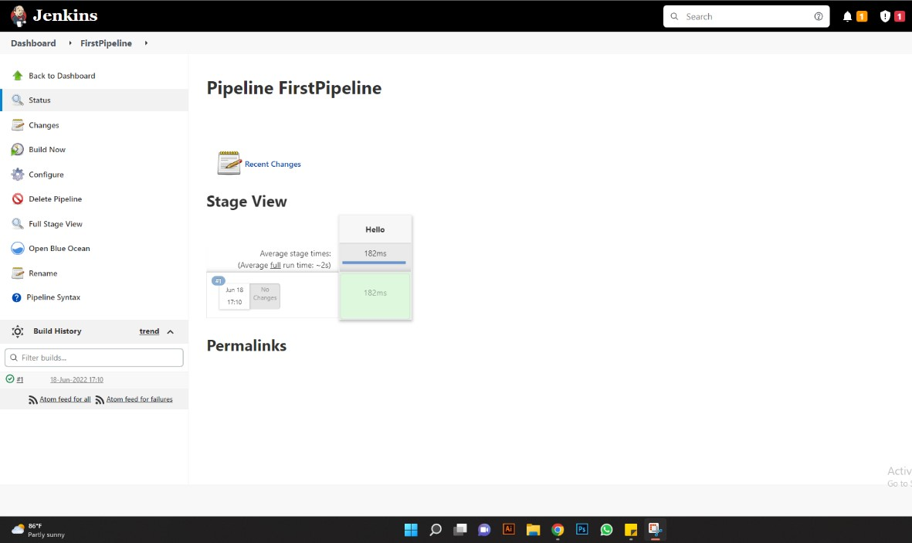

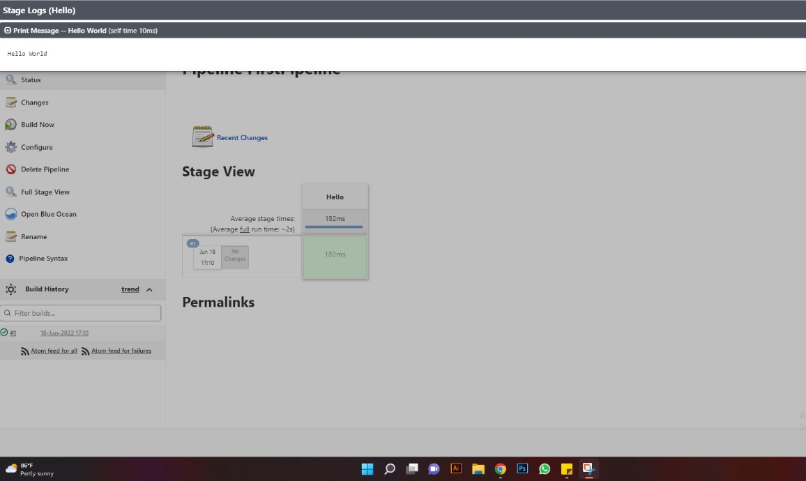

Creating CI/CD pipeline:

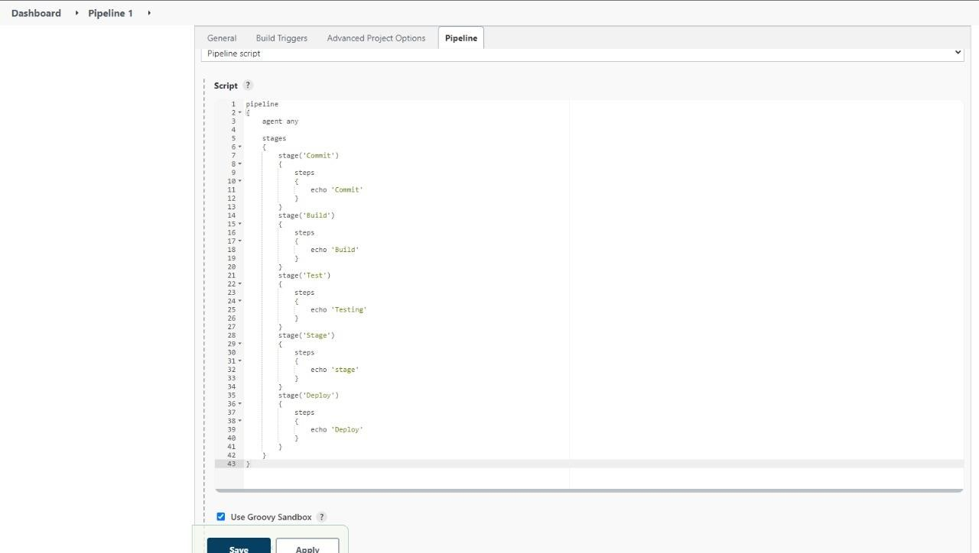

Running pipeline stages:



